**DAILY ONLINE ACTIVITIES SUMMARY**

|  |  |  |  |  |  |  |  |
| --- | --- | --- | --- | --- | --- | --- | --- |
| **Date:** | **12/06/2020** | | | | **Name:** | **Samrin Banu** | |
| **Sem & Sec** | **8th B** | | | | **USN:** | **4AL16C082** | |
| Online Test Summary | | | | | | | |
| **Subject** | | **BDA** | | | | | |
| **Max. Marks** | | **30** | | **Score** | | **22** | |
| Certification Course Summary | | | | | | | |
| **Course** | **GUVI** | | | | | | |
| **Certificate Provider** | | | **Python** | **Duration** | | | **26 hrs** |
| Coding Challenges | | | | | | | |
| **Problem Statement:** 1) Python Program to Remove Punctuations From a String | | | | | | | |
| **Status: Solved** | | | | | | | |
| **Uploaded the report in Github** | | | | **YES** | | | |
| **If yes Repository name** | | | | **Samrinbanu** | | | |
| **Uploaded the report in slack** | | | | **YES** | | | |

Online test detail:

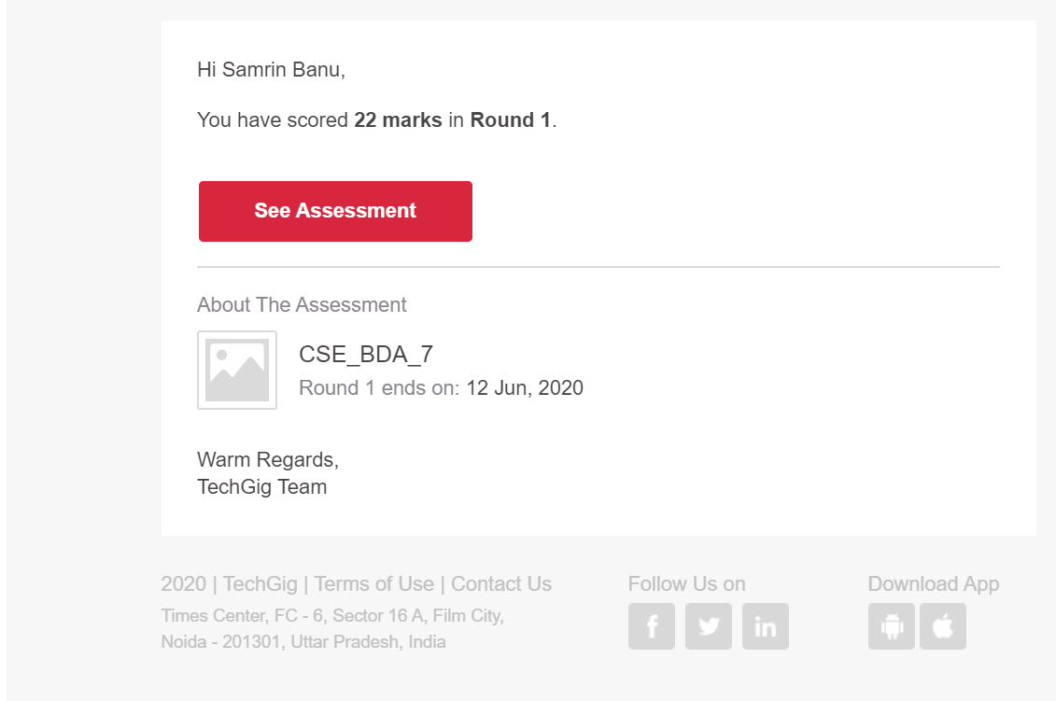

**Certification Course Details:**



# CODE:

Program no:1

# define punctuation

punctuations = '''!()-[]{};:'"\,<>./?@#$%^&*_~'''

my_str = "Hello!!!, he said ---and went."

# To take input from the user

# my_str = input("Enter a string: ")

# remove punctuation from the string

no_punct = ""

for char in my_str:

if char not in punctuations:

no_punct = no_punct + char

# display the unpunctuated string

print(no_punct)